A special type of irrationality proof for square-roots

Aim. My aim in these notes is to show that certain, special types of numbers – 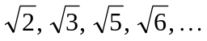 – may be proved to be irrational by exploiting the fact that they have very good rational approximations; in short, I will show that because each of them has an infinite number of so-called R-approximations, (then) each of them is irrational.

A preliminary note on a certain kind of factorisation. In the work that follows there is an entirely elementary, but very important type of factorisation that is used time and time again, namely:

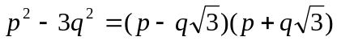 (one)

which can, of course, be verified by simply multiplying out the above right hand side:

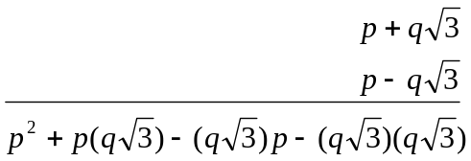
(the two middle terms cancel)

to give, after tidying up,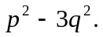You should see the above factorisation (one) as being merely a particular case of the well known school factorisation of the ‘difference of two squares’:
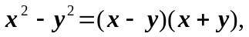

in the sense that

A preliminary note on a certain kind of product. Also in the work that follows there is an entirely elementary, but very important type of product that is used time and time again, and it is this:

(two)

which can, of course, be verified by multiplying out both the left and right sides of (two):

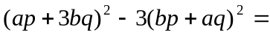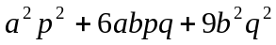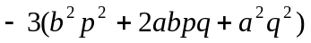
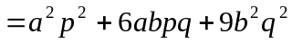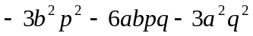
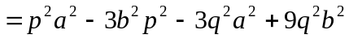

Thus the left and right hand sides of (two) are the same, and so (two) is established.
However I wouldn’t regard that as being an especially illuminating way of seeing that the important (two) is true, and I would say that a more insightful way to see that (two) is true is to factorise both terms on the left hand side of (two), and then form their products to see that appropriate combinations of factors produce exactly what is needed:

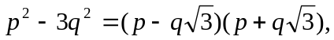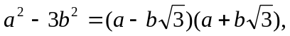thus

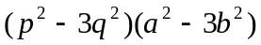
(switching the two middle terms)

Multiplying out the first two, and the last two terms then gives:

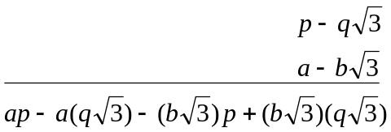 and 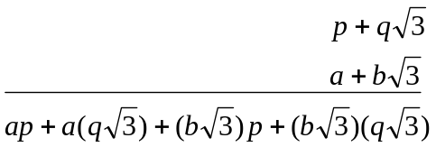
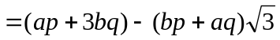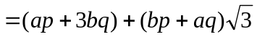

Thus
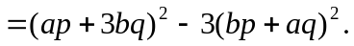

An important use of that factorisation. Recall that for all 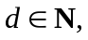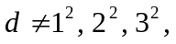… , 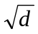automatically has an R-approximation, and a simple consequence of that is thathas an infinite number of such approximations. For a given d, all R-approximations toare obtainable from the single R-approximation to with least denominator (and accompanying numerator)–what one might call the fundamental approximation–by a simple method that had been known for many centuries, as illustrated by this example:

Example. Given thatis the fundamental R-approximation to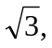one may construct from it an infinite number of other R-approximations to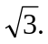
Construction. Let 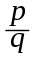be an R-approximation tothen 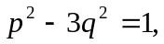and thus

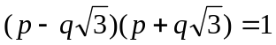 (1)
But 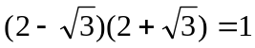 (2)
Then (3)
Giving (4)
Finally 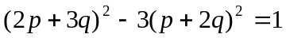 (5)
Thus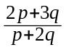is an R-approximation to

Important consequence. Every R-approximation togives rise to another one, which in turn gives rise to another one, … ad infinitum. In fact, let be any R-approximation to 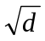(and not necessarily the fundamental one), then one may construct from it an infinite number of other R-approximations to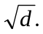

The details. Let be an R-approximation to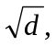then 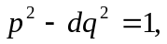and thus

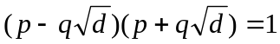 (A)
But 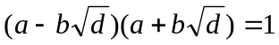 (B)
Then (C)
Giving (D)
Finally 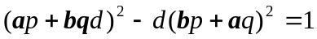 (E)

And so 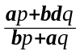is an R-approximation to

Aside. One should keep the matrix 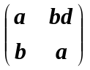in mind, for what is going on is that starting with an R-approximation 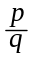to – which one may think of as being a 2-dimensional vector 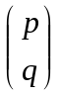– one may form a new R-approximation to– which one may think of as having come from pre-multiplying the vector by the matrix :
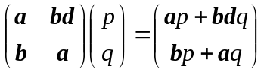

forming the new vector 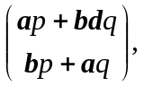which one sees produces the numerator and denominator of the new R-approximation. In fact, it’s the repeated multiplication of the initial vector by that matrix that forms all those other vectors, which correspond to the numerators and denominators. [End of Aside.]

Point. Every R-approximation togives rise to another one, which in turn gives rise to another one, … ad infinitum. In the case of

- The (first) found R-approximationtogether with
- the discovered 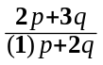

enables one to calculate a 2nd R-approximation tonamely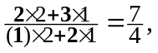
which in turn leads to a 3rd R-approximation tonamely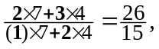
which in turn leads to a 4th R-approximation tonamely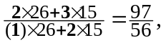etc

You must be able to carry out the detail for other simple examples like 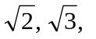… .

One final, simple, but important detail before the irrationality proof(s). Let 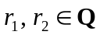with 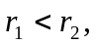 then
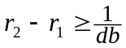 (lower)

where d and b are the positive denominators of 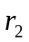and respectively. (In other words, there is a certain minimum difference between two unequal rational numbers, which depends only on the product of their positive denominators. Comment. Of course this result is rather pathetic if the two rational numbers are far apart, like for example

- if 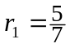and 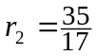then it is hardly a surprise that 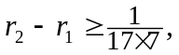when in fact the difference between them is actually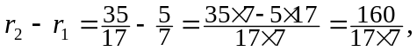 but it also happens to be the best possible in the sense that the actual minimum can happen as seen from examples like

- if and 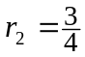 then 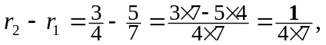
if 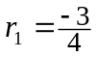 and 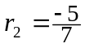 then 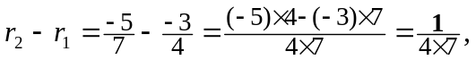
if 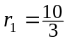and 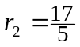 then 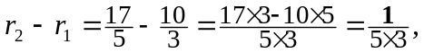etc
if 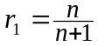and 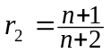 then 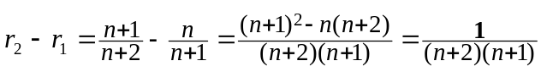

Proof of (lower). Let 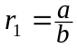and 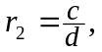where 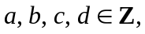and the b and d are positive. Then 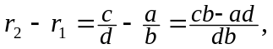and then (since 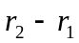is positive, and db is positive) the numerator 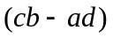must also be positive, and so (being an integer) must be at least 1. Thus 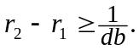

Summary. If the rational number is greater than the rational number then the difference between and is at least 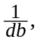where d and b are the positive denominators of and 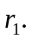 Also, strict inequality may or may not occur, meaning sometimes ‘’ occurs, sometimes ‘ = ’ occurs.

Now we are ready to present an irrationality proof based on the above body of ideas.

Theorem (example). 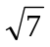is irrational.

Proof. Suppose is rational; then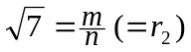for some 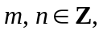and we may suppose that the fixed denominator ‘n’ is positive (in fact, we may suppose both m and n are positive, though that doesn’t matter).

Now let 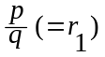be an R-approximation to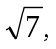and recall that

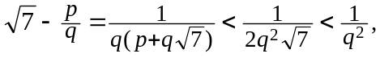and thus

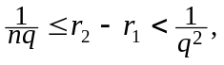

which, multiplying throughout by 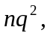gives 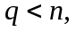 for all denominators ‘q’ of the infinitely many R-approximations to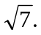 But that last inequality is clearly impossible because ‘n’ is fixed.

Final comment. The crux is that final inequality ‘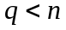’. Imagine thathad been rational, and that it had denominator 132971641000999655003131 (say). Then, for any denominator ‘q’ of an R-approximation toone would have had

Now, that inequality would have been satisfied (true) for several of the smaller q’s; the smaller q’s are, in fact, 3, 48, 765, 12192, 194307, 3096720, 49353213, 786554688, 12535521795, 199781794032, … , 13251875306657183598333 (the 19th of the q’s for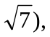but would then be false for 211198501853215619739168 (the 20th of the q’s for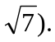 That’s the whole point about there being an infinite number of R-approximations.

In which I have used a fixed ‘3’, but you should see that ‘3’ may be replaced by general ‘d’.
Again I have used a fixed ‘3’, but you should see that ‘3’ may be replaced by general ‘d’.
This is a very famous theorem of the outstanding French mathematician Joseph Louis Lagrange (1736-1813)
Whose determinant – you may notice – is 1: the determinant is 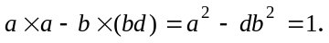It’s a ‘unimodular’ matrix.
The ‘fundamental’ one. With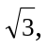we are lucky, in that the first tested ‘q’ produces an R-approximation. For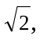the first ‘q’ is 2, for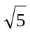it is 4, for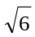it is 2, for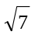it is 3, … But, for example, for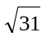it is 273 (whereas for the ones on either side, as it were –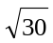and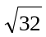 – the first q’s are 2 and 3), for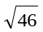it is 3,588, for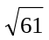it is 226,153,480, for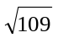it is 15,149,424,455,100, and they are as nothing compared to …

